**Password Validation:-**

**HTML:**

<!DOCTYPE html>

<html lang="en">

<head>

<meta charset="UTF-8">

<meta http-equiv="X-UA-Compatible" content="IE=edge">

<meta name="viewport" content="width=device-width, initial-scale=1.0">

<link rel="stylesheet" href="/exp4.css">

<title>Experiment 4</title>

<script defer src="/EXP4.js"></script>

</head>

<body>

<div class="container">

<h2>Login</h2>

<p>Enter your username and password</p>

<br>

<input type="text" id="user" placeholder="Username">

<br>

<br>

<input type="password" id="password" placeholder="Password">

<p>Password must contain a lower case, an upper case, a number, a special charachter</p>

<br>

<span><button id="show">Show Password</button></span>

<br>

<br>

<p><a href="">Forget Password?</a></p>

<br>

<button id="submit" onclick="validate()">Sign in</button>

<br>

<p>Dont have an Account? <a href="#">Sign up</a></p>

</div>

</body>

</html>

**CSS:**

body {

display: flex;

justify-content: center;

align-items: center;

background-color: #4158D0;

background-image: linear-gradient(43deg, #4158D0 0%, #C850C0 46%, #FFCC70 100%);

background-repeat: no-repeat;

height: 100vh;

}

.container {

background: white;

width: 22vw;

height: max-content;

border: 4px solid black;

border-radius: 25px;

justify-items: center;

justify-content: center;

text-align: center;

}

#user {

width: 20em;

height: 3em;

}

#password {

width: 20em;

height: 3em;

}

#submit {

width: 12vw;

height: 6vh;

font-size: 15px;

font-family: Arial;

border-width: 1px;

color: #fff;

cursor: pointer;

border-color: #0b0e07;

border-top-left-radius: 3px;

border-top-right-radius: 3px;

border-bottom-left-radius: 3px;

border-bottom-right-radius: 3px;

box-shadow: inset 0px -3px 7px 0px #29bbff;

background: linear-gradient(#2dabf9, #0688fa);

}

#submit:hover {

background: linear-gradient(#0688fa, #2dabf9);

}

**JavaScript :**

let Pass = document.getElementById("password");

let show = document.getElementById("show");

let user = document.getElementById("user");

show.onclick = () => {

if (Pass.value.length > 0) {

if (Pass.type === "password") {

Pass.setAttribute("type", "text");

} else {

Pass.setAttribute("type", "password");

}

}

};

function validate() {

let pswrd = "^(?=.*?[A-Z])(?=.*?[a-z])(?=.*?[0-9])(?=.*?[#?!@$%^&*`~-]).{8,}$";

if (user.value.length <= 0 || Pass.value.length <= 0) {

console.log("no input");

alert("Please enter all the fields")

}

if (Pass.value.match(pswrd)) {

console.log("valid");

alert("Welcome");

}

if (!Pass.value.match(pswrd)) {

console.log("not valid");

alert("Password is not valid");

}}

**Output:-**

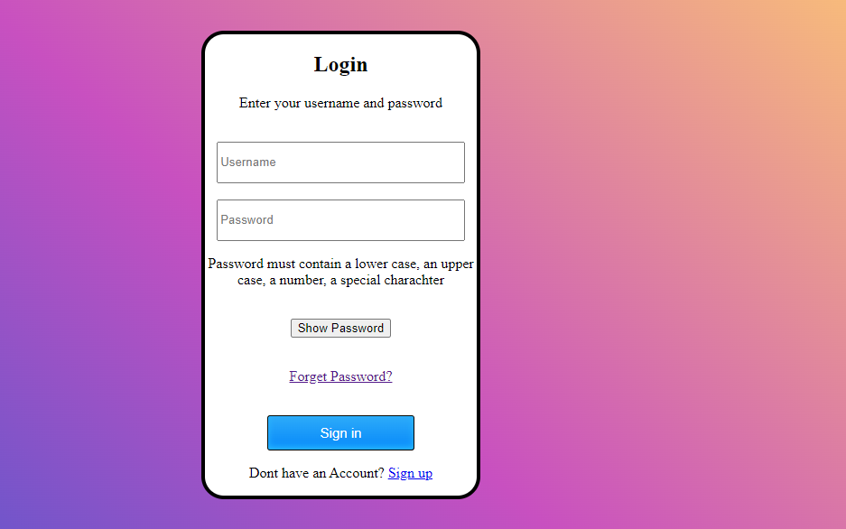

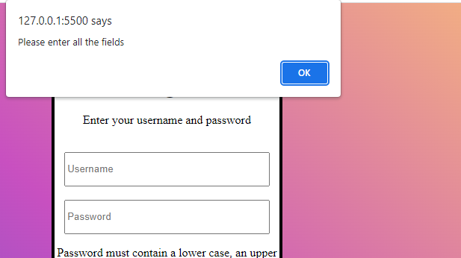

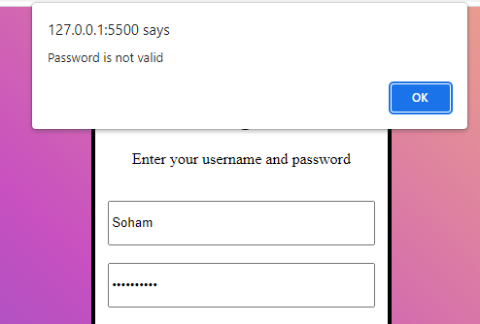

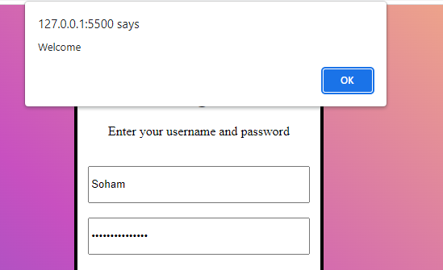

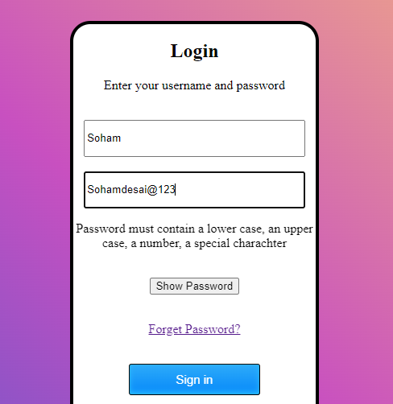

**Inheritence:-**

class Vehicle {

constructor(type, color, age) {

this.type = type;

this.color = color;

this.age = age;

}

}

class Car extends Vehicle {

constructor(type, color, age, engine) {

super(type, color, age);

this.engine = engine;

}

print() {

console.log(`Type: ${this.type}\n

Color : ${this.color}\n

Age : ${this.age}\n

Engine : ${this.engine}`);

}

}

let soham = new Car("Sedan","Red","10 years","V8")

soham.print();

